* 1. 
  2. Now we have good understanding of what generics are and how to use them. Let’s see what how they work under the hood?
  3. 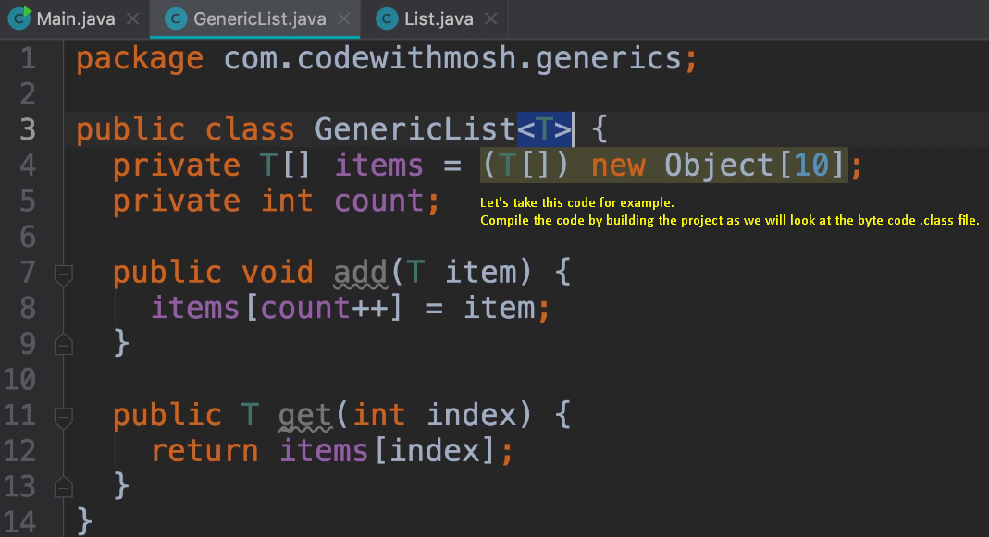
  4. 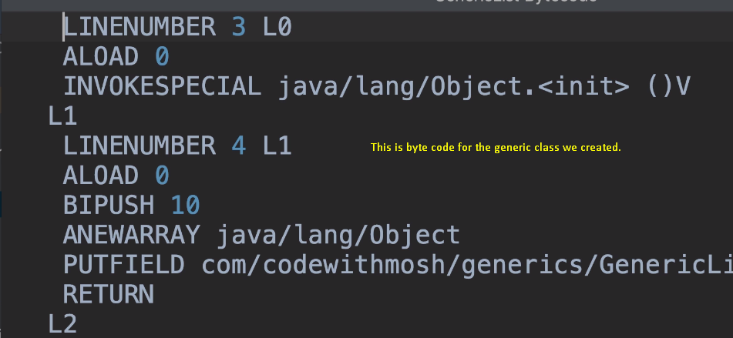
  5. 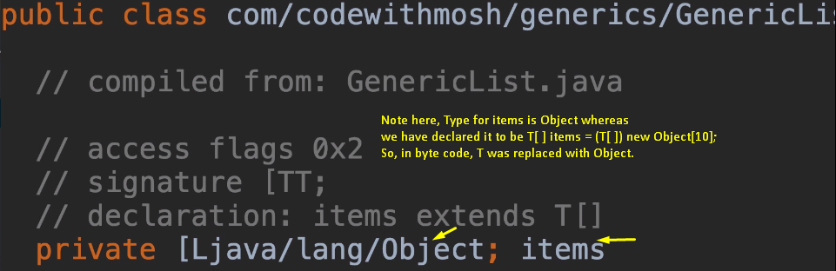
  6. 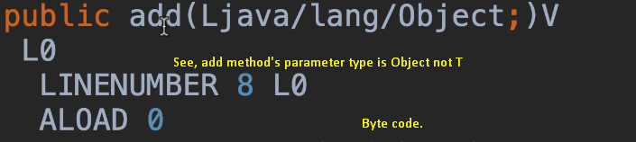
  7. 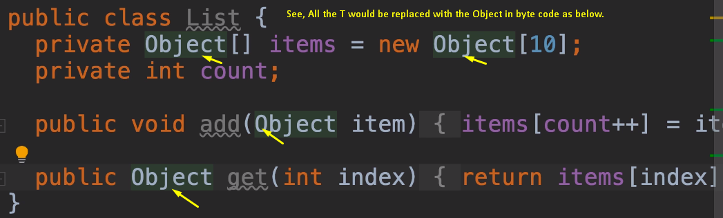
  8. 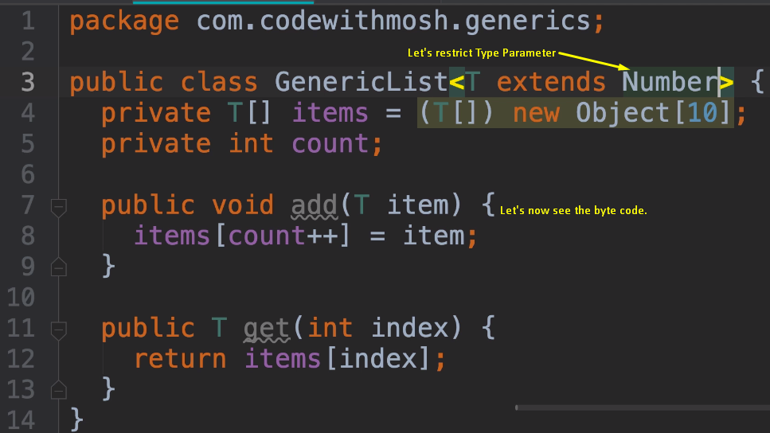
  9. 
  10. 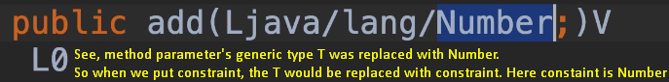
  11. 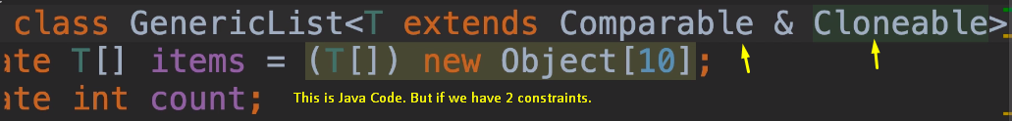
  12. 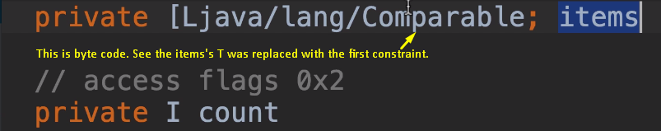
  13. 
  14. If there is no constraint, then T is replaced with the Object class as in the first example above.